Subject Complement

✅ What Is a Subject Complement?
# Source: AI Source: Provided by: [Data Path: Persons Table -> ID Column: 1, Name_En Column: Motasem Essam] -> From: [ChatGPT] on [8/4/2025]
A Subject Complement is a word or phrase that follows a linking verb and either renames or describes the subject of the sentence.
It completes the meaning of the subject and is essential to the sentence structure.

🔸 Key Features:
# Source: AI Source: Provided by: [Data Path: Persons Table -> ID Column: 1, Name_En Column: Motasem Essam] -> From: [ChatGPT] on [8/4/2025]
- Follows linking verbs like:
be, become, seem, appear, feel, look, smell, taste, remain, stay
- Answers the question:
➤ Who/what is the subject?
➤ What is the subject like?
- Usually a noun, pronoun, or adjective

🔸 Types of Subject Complements:
# Source: AI Source: Provided by: [Data Path: Persons Table -> ID Column: 1, Name_En Column: Motasem Essam] -> From: [ChatGPT] on [8/4/2025]
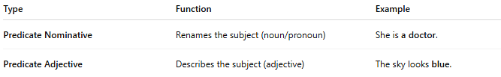
Type | Function | Example
Predicate Nominative | Renames the subject (noun/pronoun) | She is a doctor.
Predicate Adjective | Describes the subject (adjective) | The sky looks blue.

🔸 Examples in Sentences:
# Source: AI Source: Provided by: [Data Path: Persons Table -> ID Column: 1, Name_En Column: Motasem Essam] -> From: [ChatGPT] on [8/4/2025]
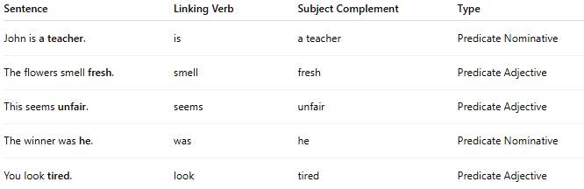
Sentence | Linking Verb | Subject Complement | Type
John is a teacher. | is | a teacher | Predicate Nominative
The flowers smell fresh. | smell | fresh | Predicate Adjective
This seems unfair. | seems | unfair | Predicate Adjective
The winner was he. | was | he | Predicate Nominative
You look tired. | look | tired | Predicate Adjective

